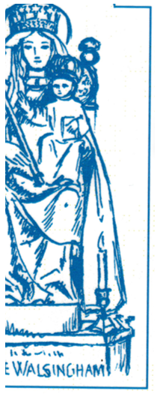St Magnus the Martyr on London Bridge

**Festival Mass of**

**The Fraternity of**

**Our Lady de Salve Regina**

Saturday, September 20th

at midday.

Preacher:

The Rt Rev’d David Waller, Bishop Ordinary of the Ordinariate of O.L.W.

ALL WELCOME

There is a limited number of lunch tickets available, priced £30 (including wine). Please apply to

The Warden of the Fraternity, [salvewarden@stmtm.org.uk](mailto:salvewarden@stmtm.org.uk)