The Parish Church of St Cuthbert with St Matthias,  
Philbeach Gardens, Earl's Court SW5.

THE FEAST OF THE TRANSLATION  
OF THE RELICS OF ST CUTHBERT  
Sunday 3rd September 2023

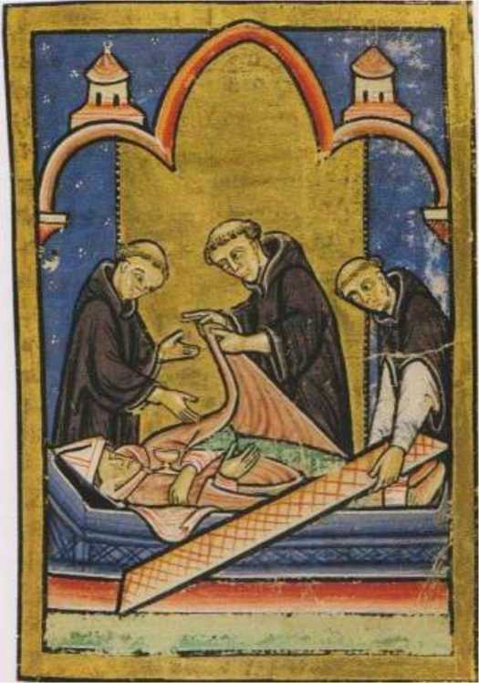

6.15pm Pontifical Evensong and

Procession of the Relics of

St Cuthbert.

Preacher The Right Rev’d Glynn Webster

Followed by a Reception.