ACAT (Harrow) - prayer case of the month (May 2023)
3 May is the UN World Press Freedom Day. Please pray as you feel led for local radio journalist and history teacher Mancho Bibixy who is serving an 18-year prison sentence in Cameroon.
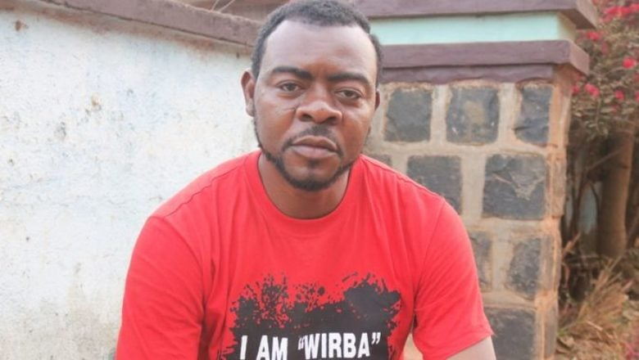
In November 2016, Mancho Bibixy stood in an open casket at a crowded roundabout in Bamenda, a city in the English-speaking region of Cameroon. Using a loudspeaker, he denounced the social and economic marginalization of his Anglophone community, at a time when discontent was brewing following a new requirement for all schools and courts to use French. He was already known for documenting human rights violations in North-West Cameroon, as well as for taking care of young people in difficult family situations and being a Manchester United fan. After that day, “BBC”, as he is popularly called, emerged as one of the leaders in the movement for equal rights in this Francophone-dominated country.
Following this peaceful protest, armed soldiers violently seized him at night, without a warrant, at a friend’s house. They beat him up and hooded him. In May, the Yaoundé Military Court sentenced Mancho Bibixy to 15 years in prison in an unfair trial for “terrorism”, “secession”, “rebellion”, “inciting civil war”, and “spreading false information through social media” – all of these charges originating from the coffin stunt. To those who know him, he was punished for passionately speaking out for equality and non-discrimination in a society that strictly controls freedom of expression. In 2019, the UN declared his detention arbitrary and called for his release.
Mancho Bibixy shares a small cell with 15 inmates in Kondengui central maximum-security prison in Yaoundé and has no proper access to hygiene facilities. He has limited contact with his family – a wife, two children and another eight he was taking care of – in Bamenda. Tortured, ill-treated and in poor health, his sentence was increased in 2021 after he complained about poor prison conditions – and he was subjected to further torture. But he has thanked ACAT supporters for messages and cards which have encouraged him.
Updates: RUSSIA: Vladimir Kara-Murza, journalist, author and filmmaker, and former pupil of the John Lyon School in Harrow and who was our prayer case in November 2022, has just received a 25-year prison sentence for ‘high treason’ because of his outspoken criticism of the war in Ukraine.
Good news from IRAN!: House church leader Pastor Youcef Nadarkhani, our prayer case for December 2018, who was re-arrested in 2017 and sentenced to a further 10 years detention, was released at the end of February.

